Running the Project
First compile all the java files: theProject.java, ClassLoaderTest.java, TestPrint.java, ClassBrowserTest.java, myPBEEncryptor.java and myPBEDecryptor.java.

Then invoke java interpreter on theProject: java theProject
OUTPUT
{NOTE -- a bug --- the project on starting does not expand to preferred size it is important for you to hit the maximise button.}

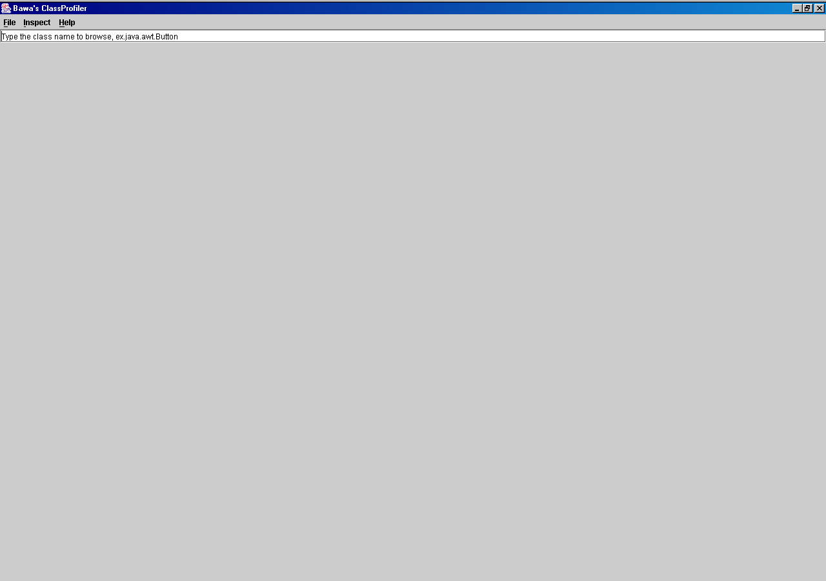

The opening screen. The user is presented with a host of menu options:
FILE
- Open – Alt O (keyboard shortcut) --- opens a java file which can be read…. One can also print this file out
- Load – Alt L --- opens a Class through a customized class loader
- Encrypt --- Alt E – Encrypt any file
- Decrypt --- Alt D – Decrypt any file
- Print Alt P --- Print the contents of the “Class Information”
INSPECT
- Reflect Alt R --- Invoke a class which exists on the tree pane (left side, using mouse click, or keyboard)
- Visualize Alt V – View info of the class in a class diagram – not yet implemented

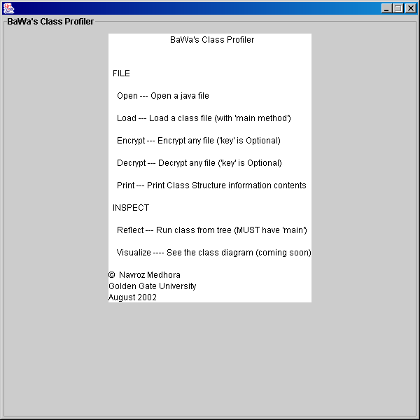
Pressing Help --- About

Output on entering java.awt.Button in the textfield

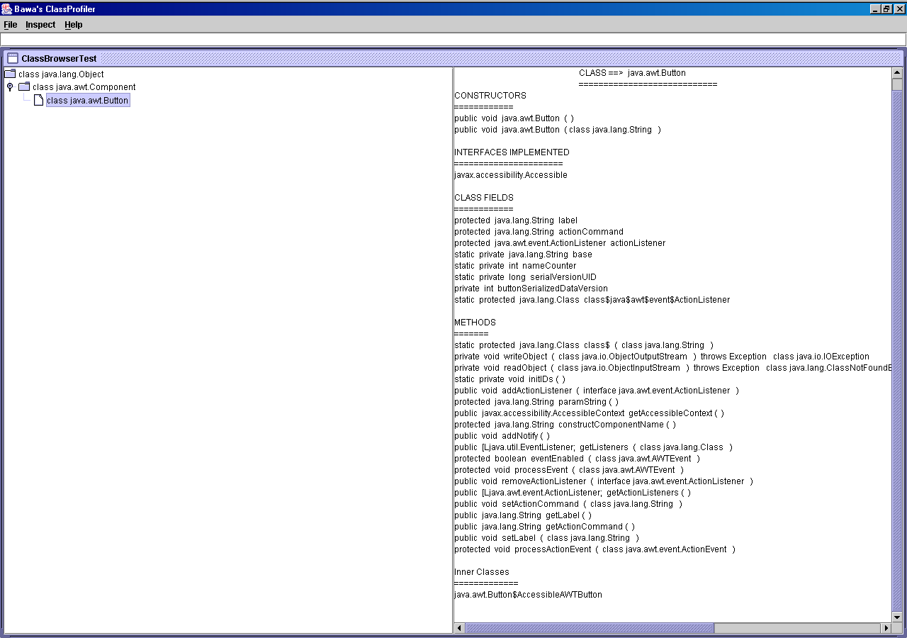

The information provided include: The class name (including path); all the constructors and their parameters; all interfaces implented; all class fields; all methods (including return type, modifiers , parameters and exceptions); and all InnerClasses
Class Information for BuildTree

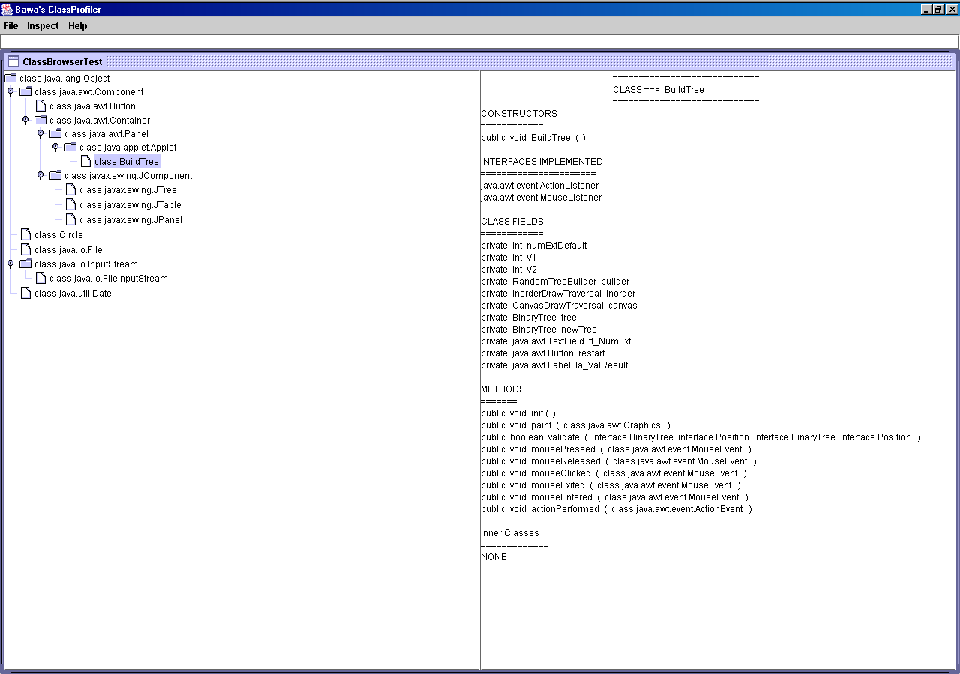

Navigating to “CircleTest” on the tree; then hitting Inspect – Reflect

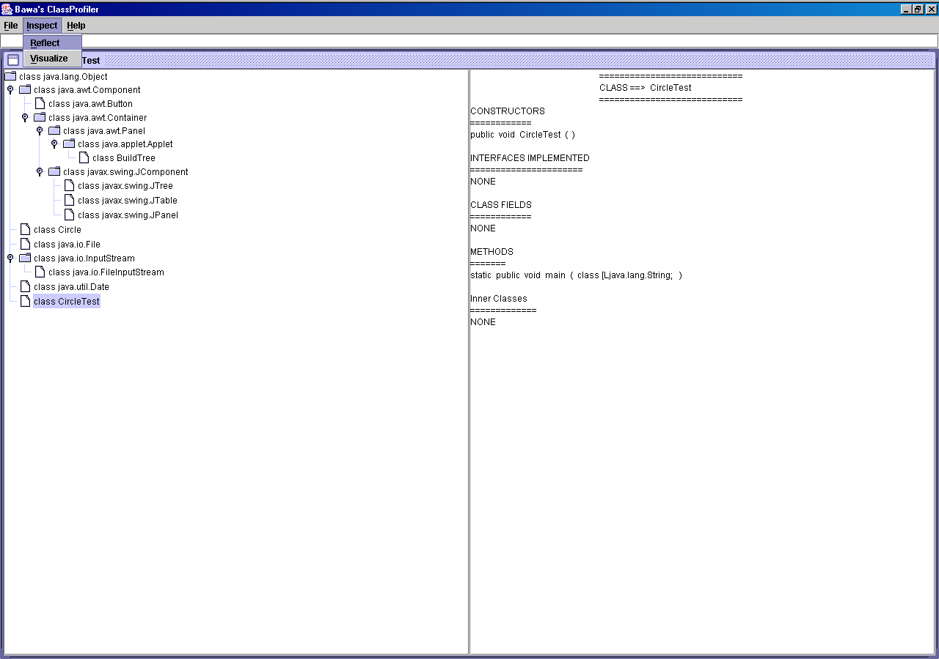
See output on next page

Output on hitting Reflect after navigating to CircleTest

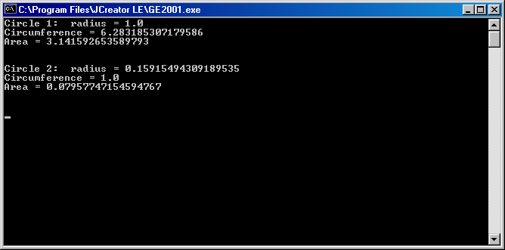

Hitting File – Open (this will now give us option to open & print any file)

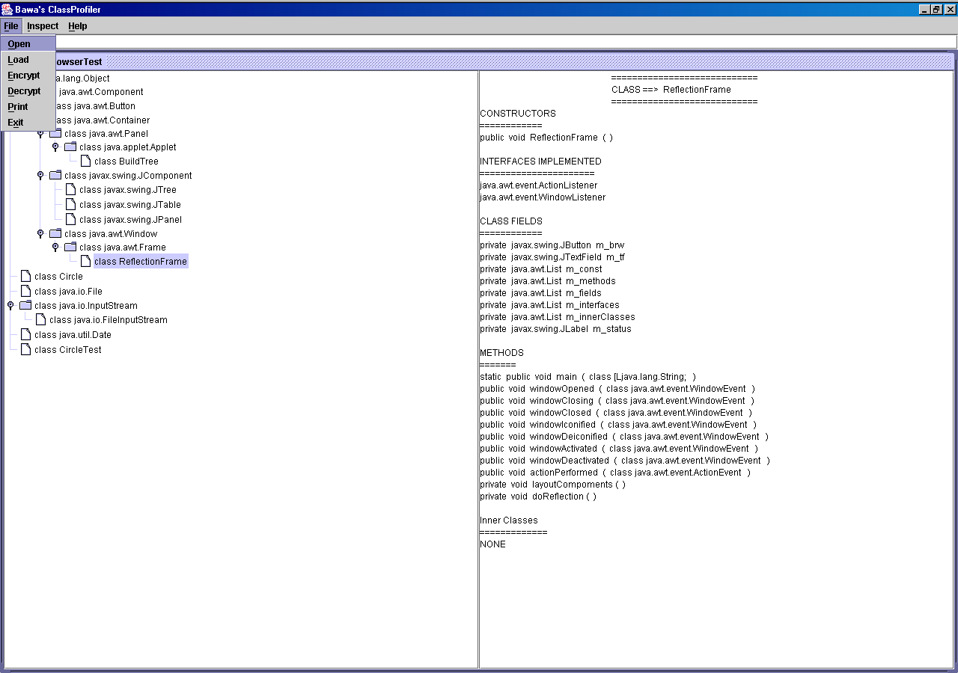

Initial Output on hitting File – Open Navigating to a file to open (Only *.java files are displayed)

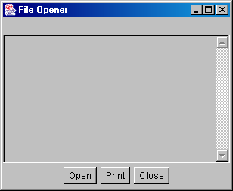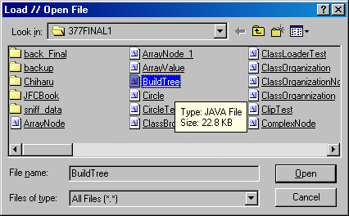

The out upon selecting BuildTree.java

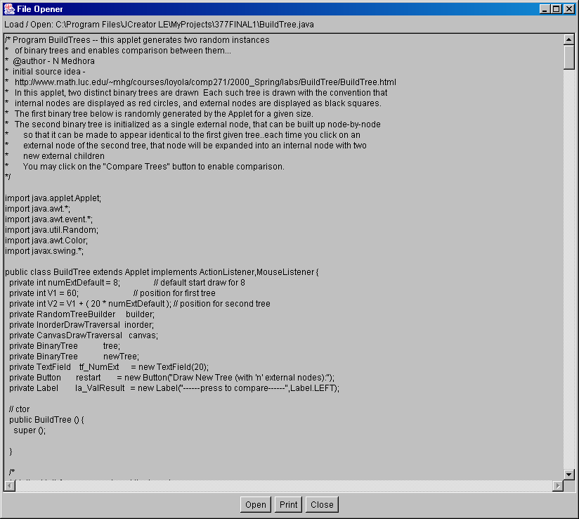
The contents of the readable .java file BuildTree are displayed --- the user can open other java files – Presently there is also a Print facility implemented; however this is not so for editing and saving .

{PS – I do not have a printer at home and so I cannot provide output for that here}

Hitting File – Load : enables us to Load any class file --- we enter the full path name.

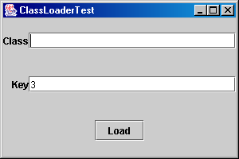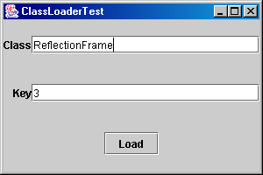

The output from the ClassLoader causes a new instance of ReflectionFrame (another class – code not provided)
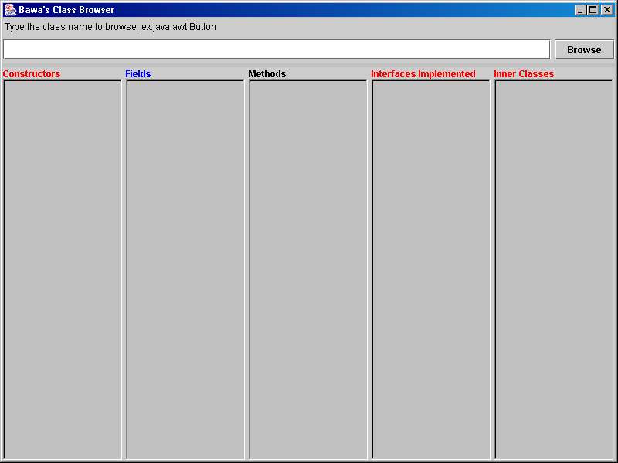

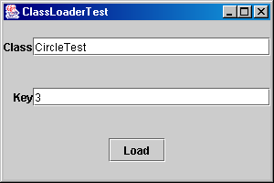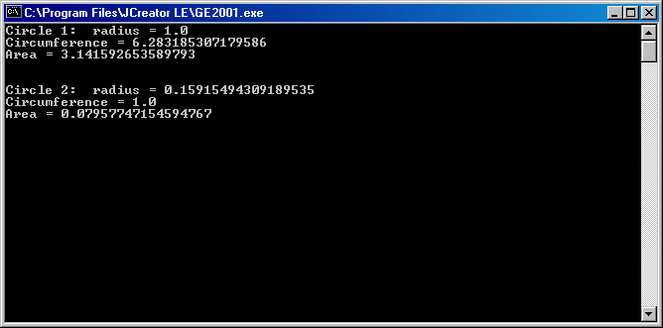

The custom class loader – loads and runs CircleTest
Compare with page 4 (Inspect – Reflect)
Encryption
Httting File – Encrypt; we first enter the pass phrase – here I entered ‘nonny’
The File menu in the Encryptor has two menu options (Encrypt and Exit )

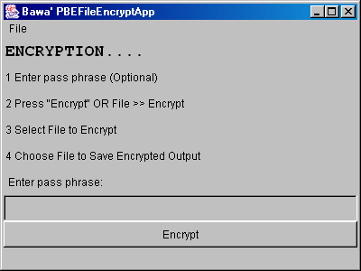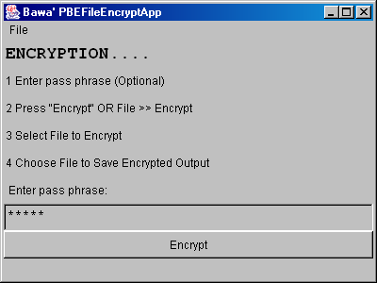

After htiing “Encrypt” button – or File >> Encrypt we are initially asked to select a file for encryption
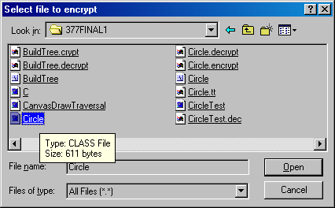
Navigating to file “Circle.class” for Encryption

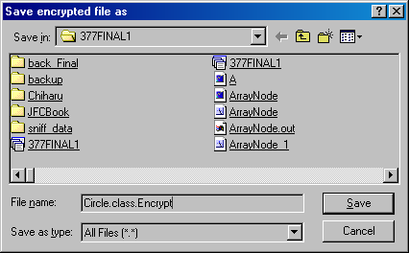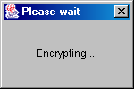

Choosing target file “Circle.class.Encrypt” to save the encrypted version The output while encrypting
of the original file “Circle.class”
Now a new Encrypted file has been created

Decryption
A similar process for Decrypting files…. We now try to decrypt the file we encryted in the previous page… we use the same pass phrase “nonny”….. If we use any othe pass phrase then the output of the decryption will appear encrypted

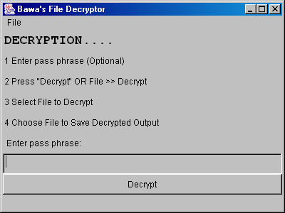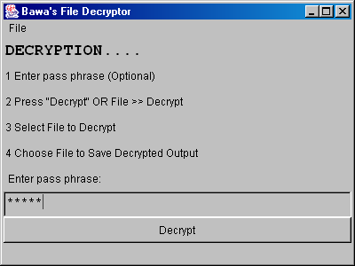

After htiing “Decrypt” button – or File >> Decrypt we are initially asked to select a file to decrypt

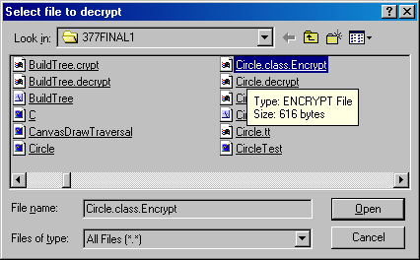
Navigating to file “Circle.class.Encrypt” for Decryption

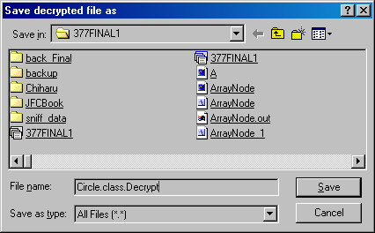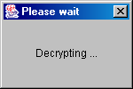

Choosing target file “Circle.class.Decrypt” to save the decrypted version The output while decrypting
of the originally encrypted file “Circle.class.Encrypt”
Now the encrypted file “Circle.class.Encrypt” has been decrypted
Encryption // Decryption Demon on file CircleTest.java ---- this is being done because .class files cannot be read by humans
Using Pass phrase “manhattan”
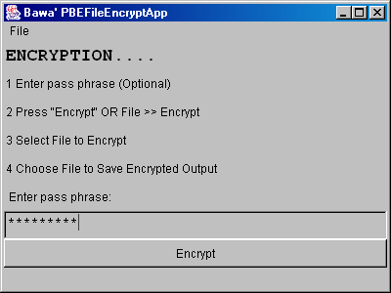 Entering pass phrase “manhattan”

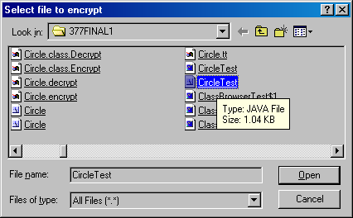 Choosing “CircleTest.java” for encryption

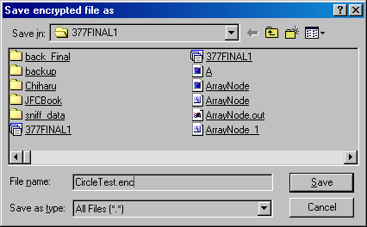 Selected target encrypted file as “CircleTest.enc”

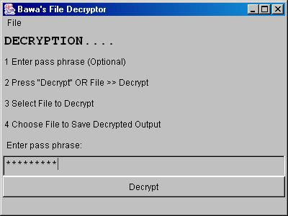 Entering pass phrase “manhattan”

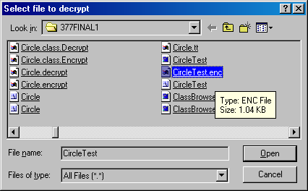 Selecting “CircleTest.enc” for decryption

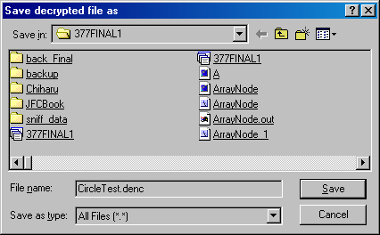 Selecting target decrypted file as “CircleTest.denc”

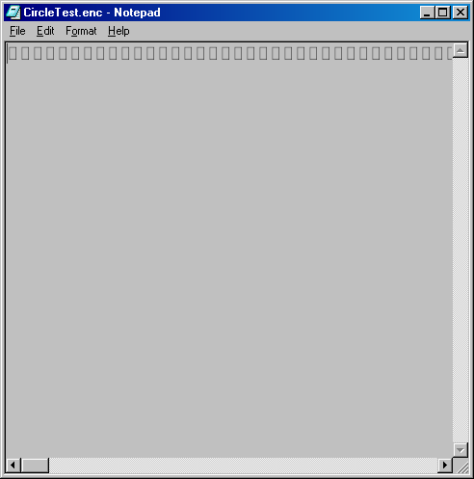
Opening “CircleTest.enc” and “CircleTest.denc” with Notepad

Since CircleTest.enc is an encrypted file it cannot be read by Notepad

“CircleTest.denc” is the decrypted version of “CircleTest.enc” --- in both the encryption and decryption process the SAME PASS PHRASE was used, and so is readable when opened from Notepad
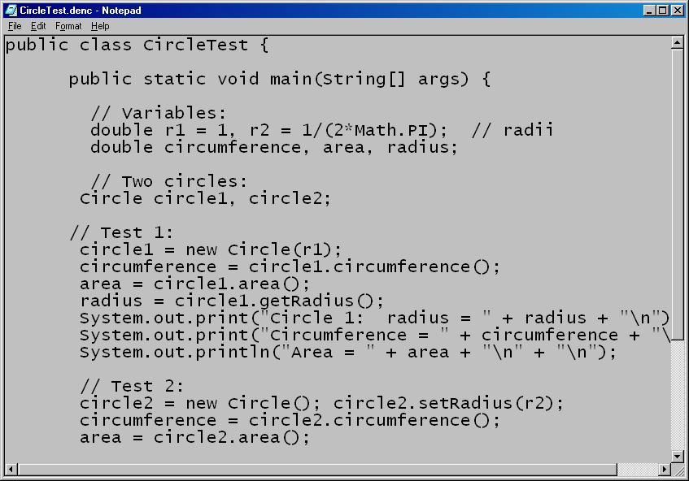

Note if we had decrypted CircleTest.enc with another pass phrase it will not be readable:
Attempting decryption without any pass phrase and then opeing output in Notepad
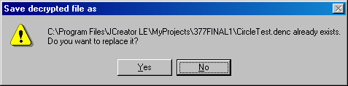
Since file CircleTest.denc already exists we are overwriting it

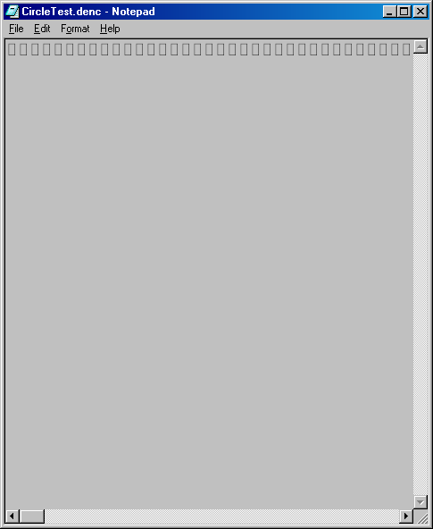
Since the pass phrase was not the same we cannot get viewable output in Notepad
Exercising File – Print to get the contents of the Class Information

